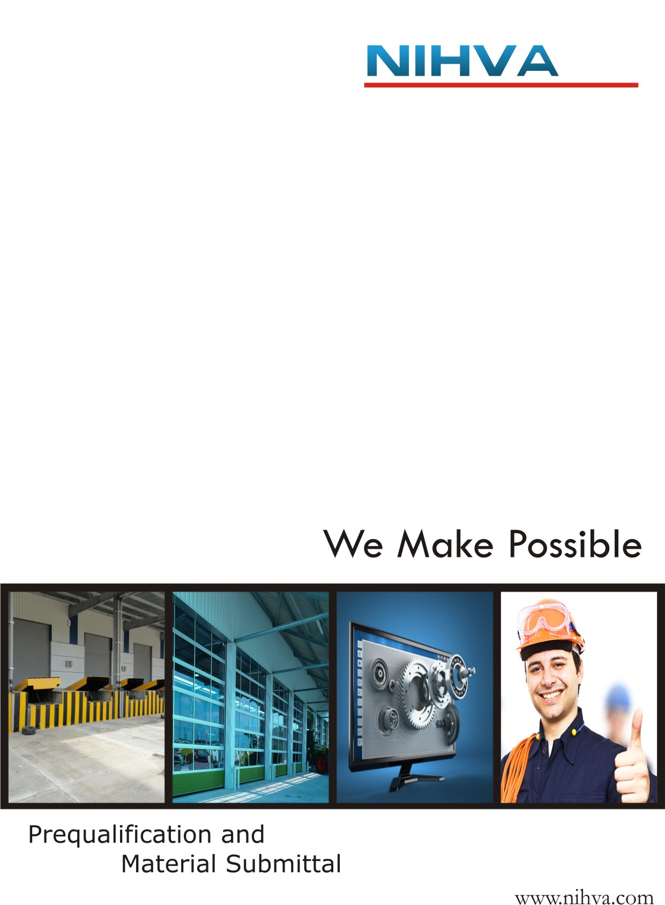

Contents

- Company Profile
- Company License
- Authorization Certifications
- Product Solutions
- Technical Specification
- Product Catalogue
- Client List
- Contact Us

Company
Profile

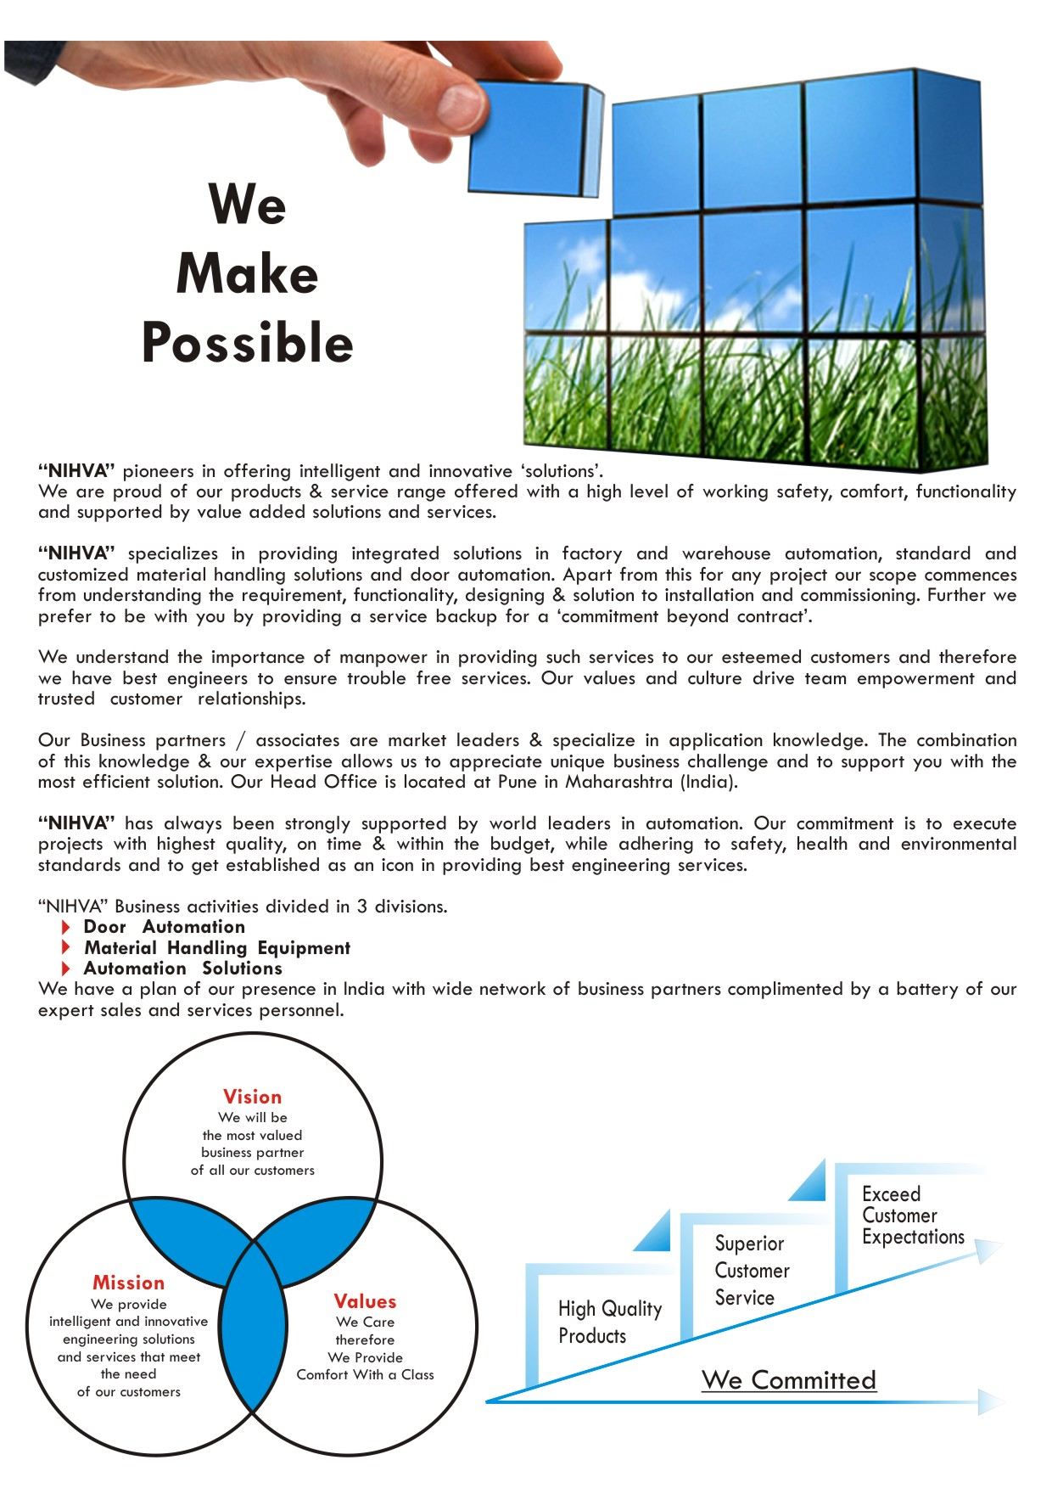

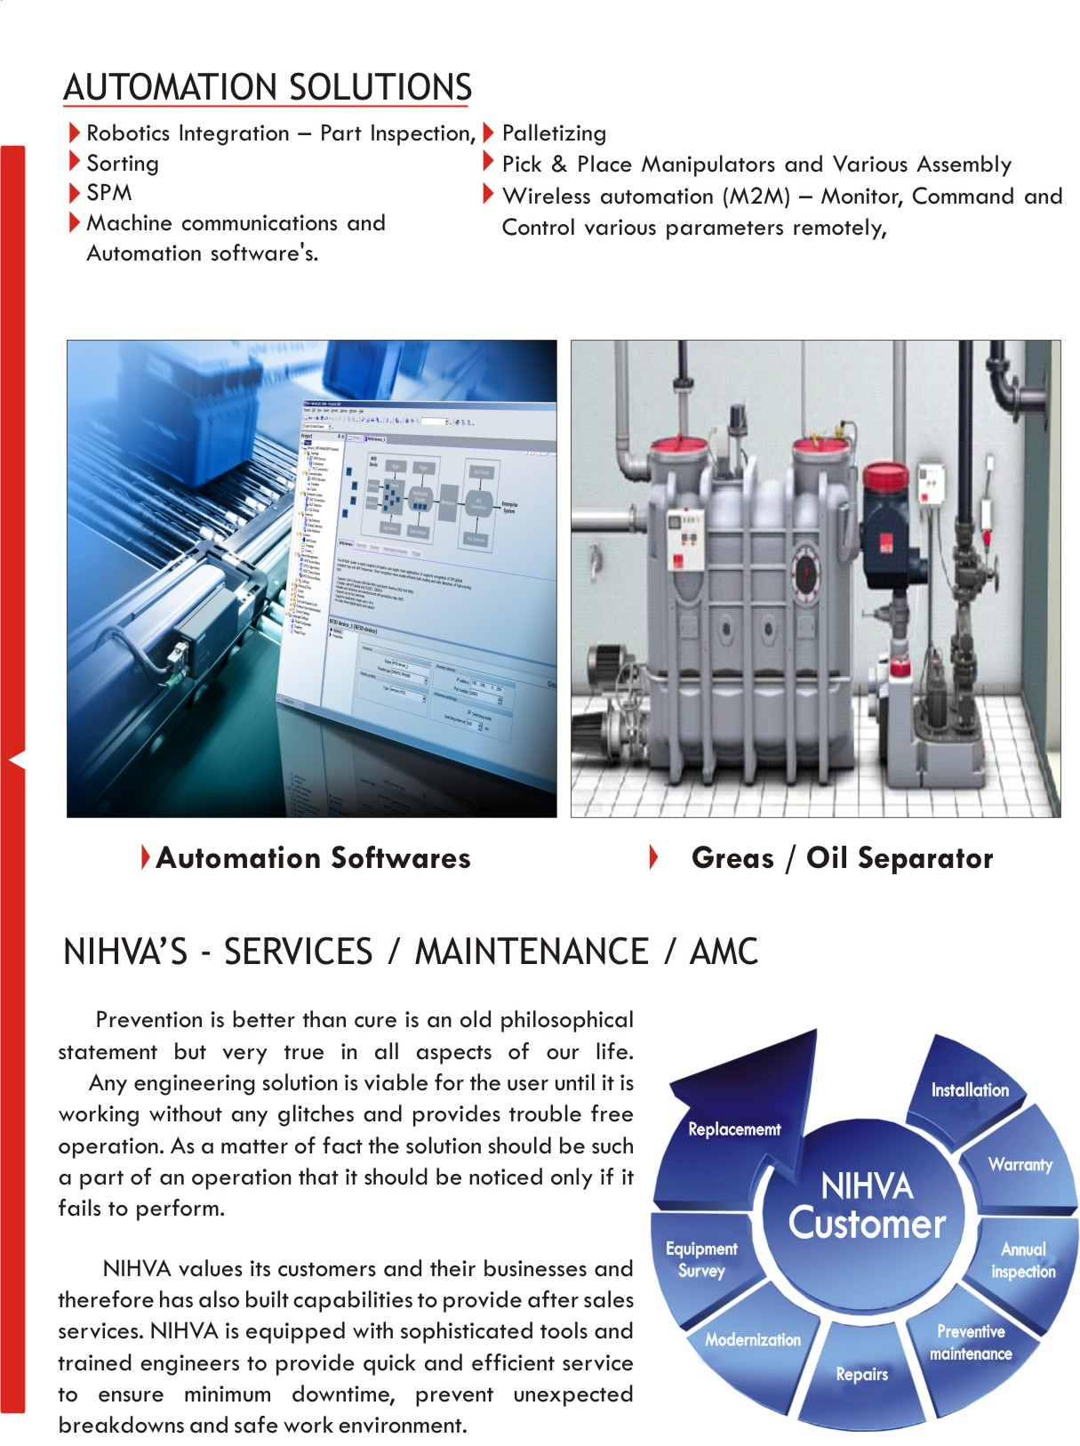
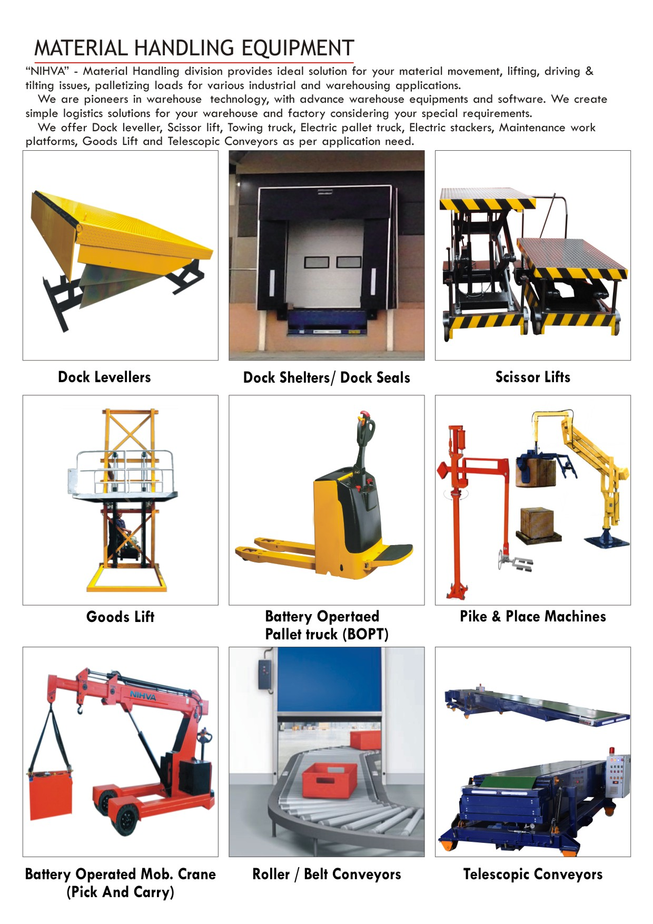
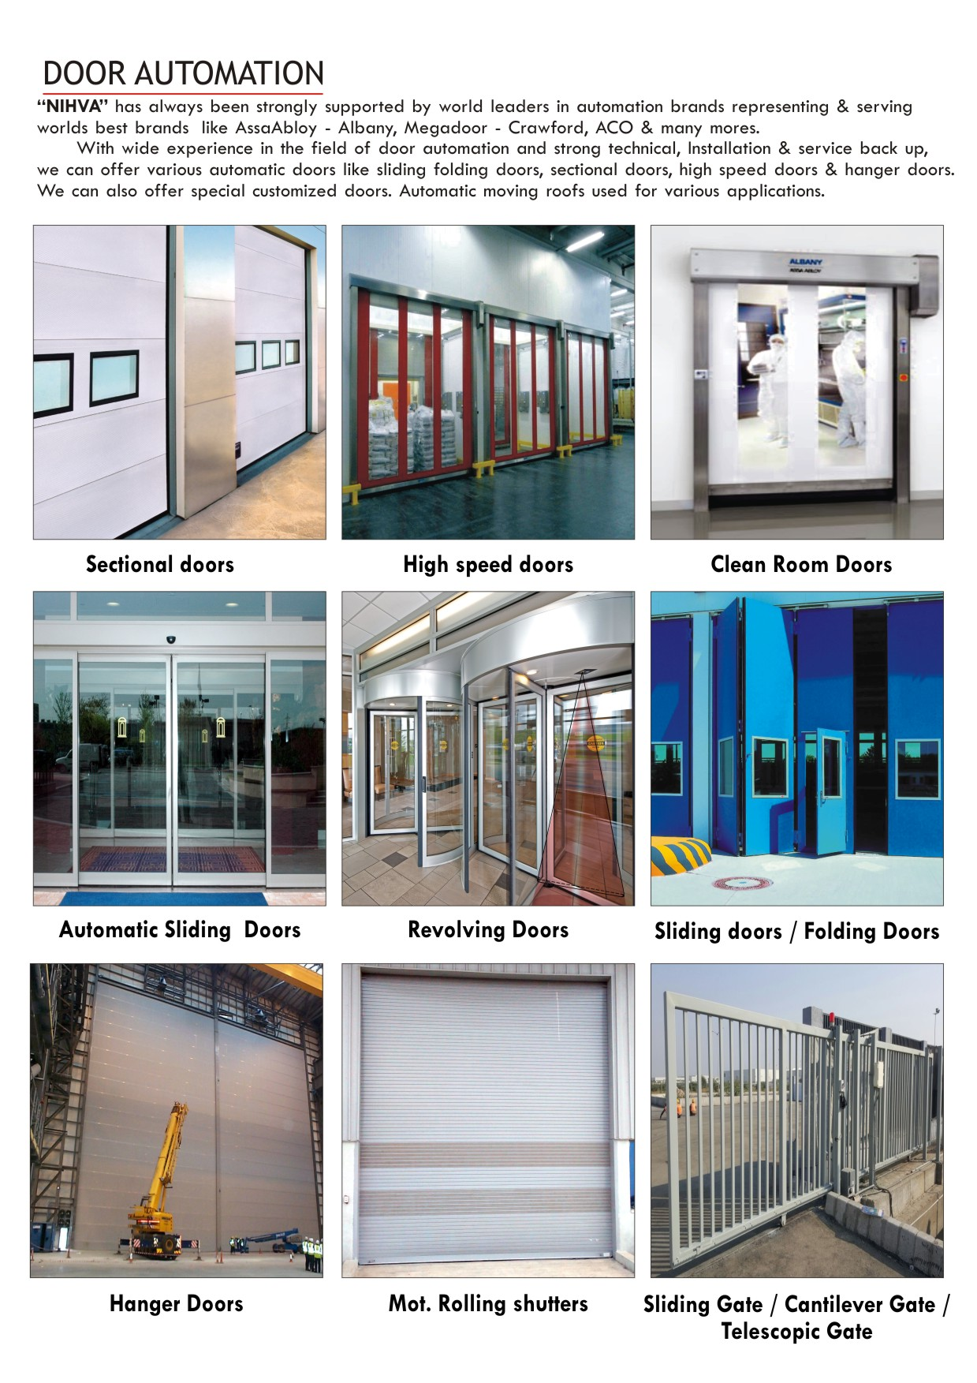

Company
License

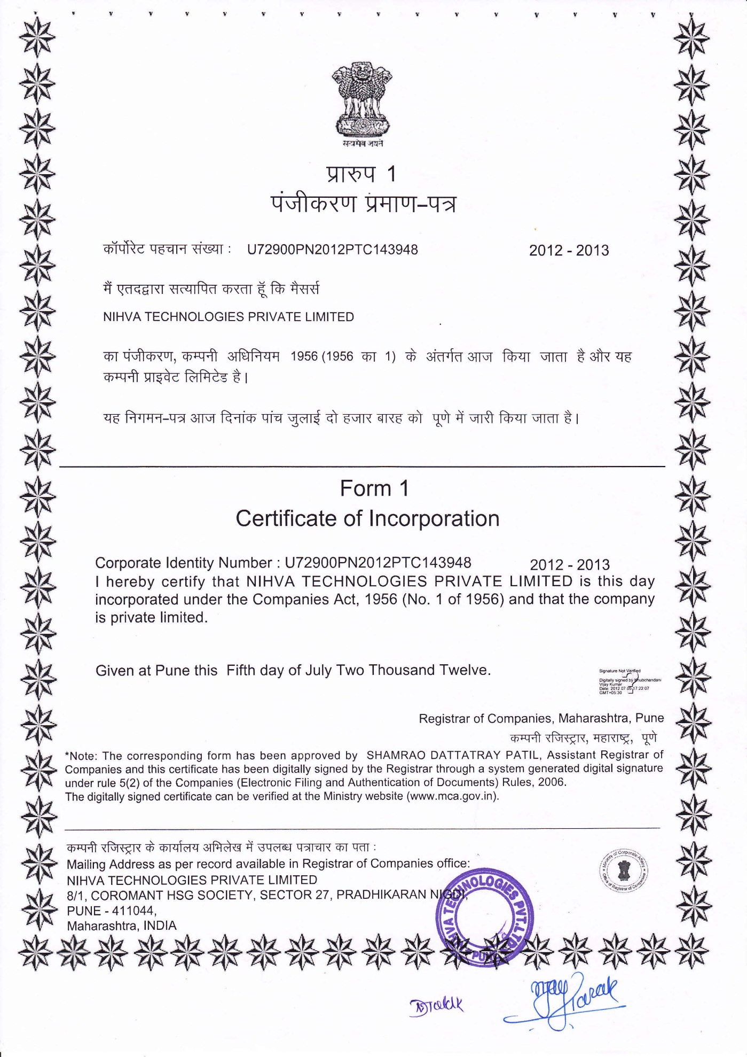

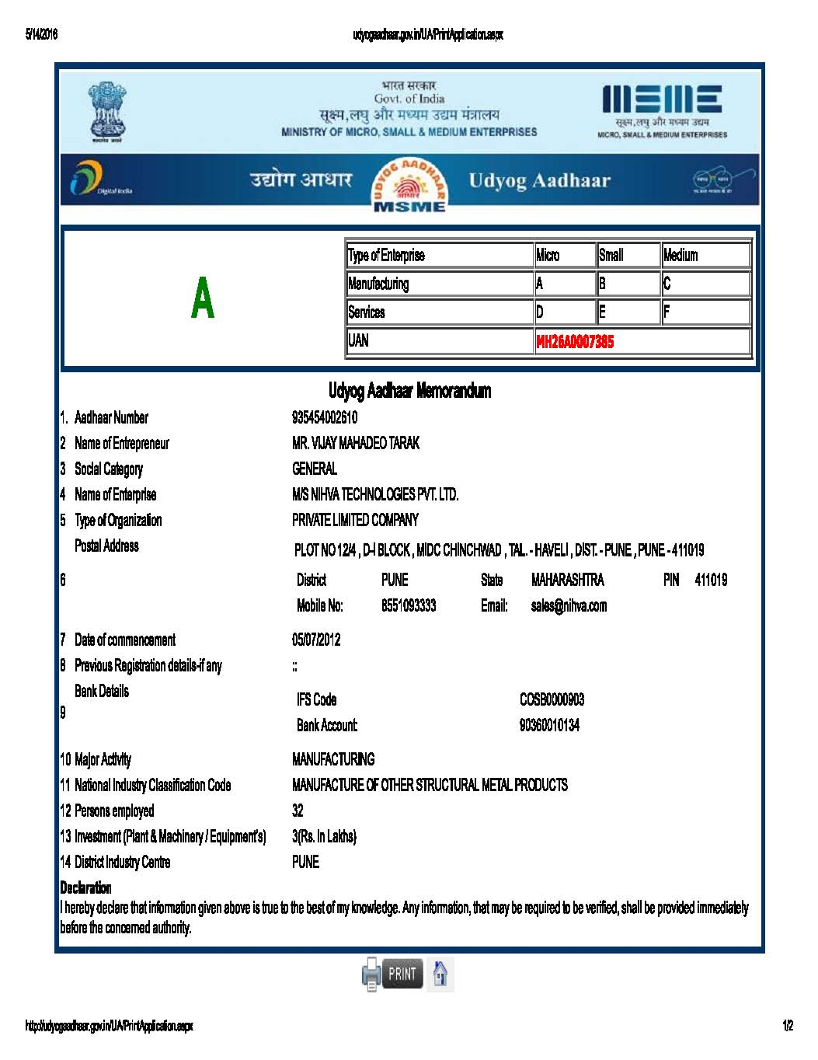

Authorization
Certifications

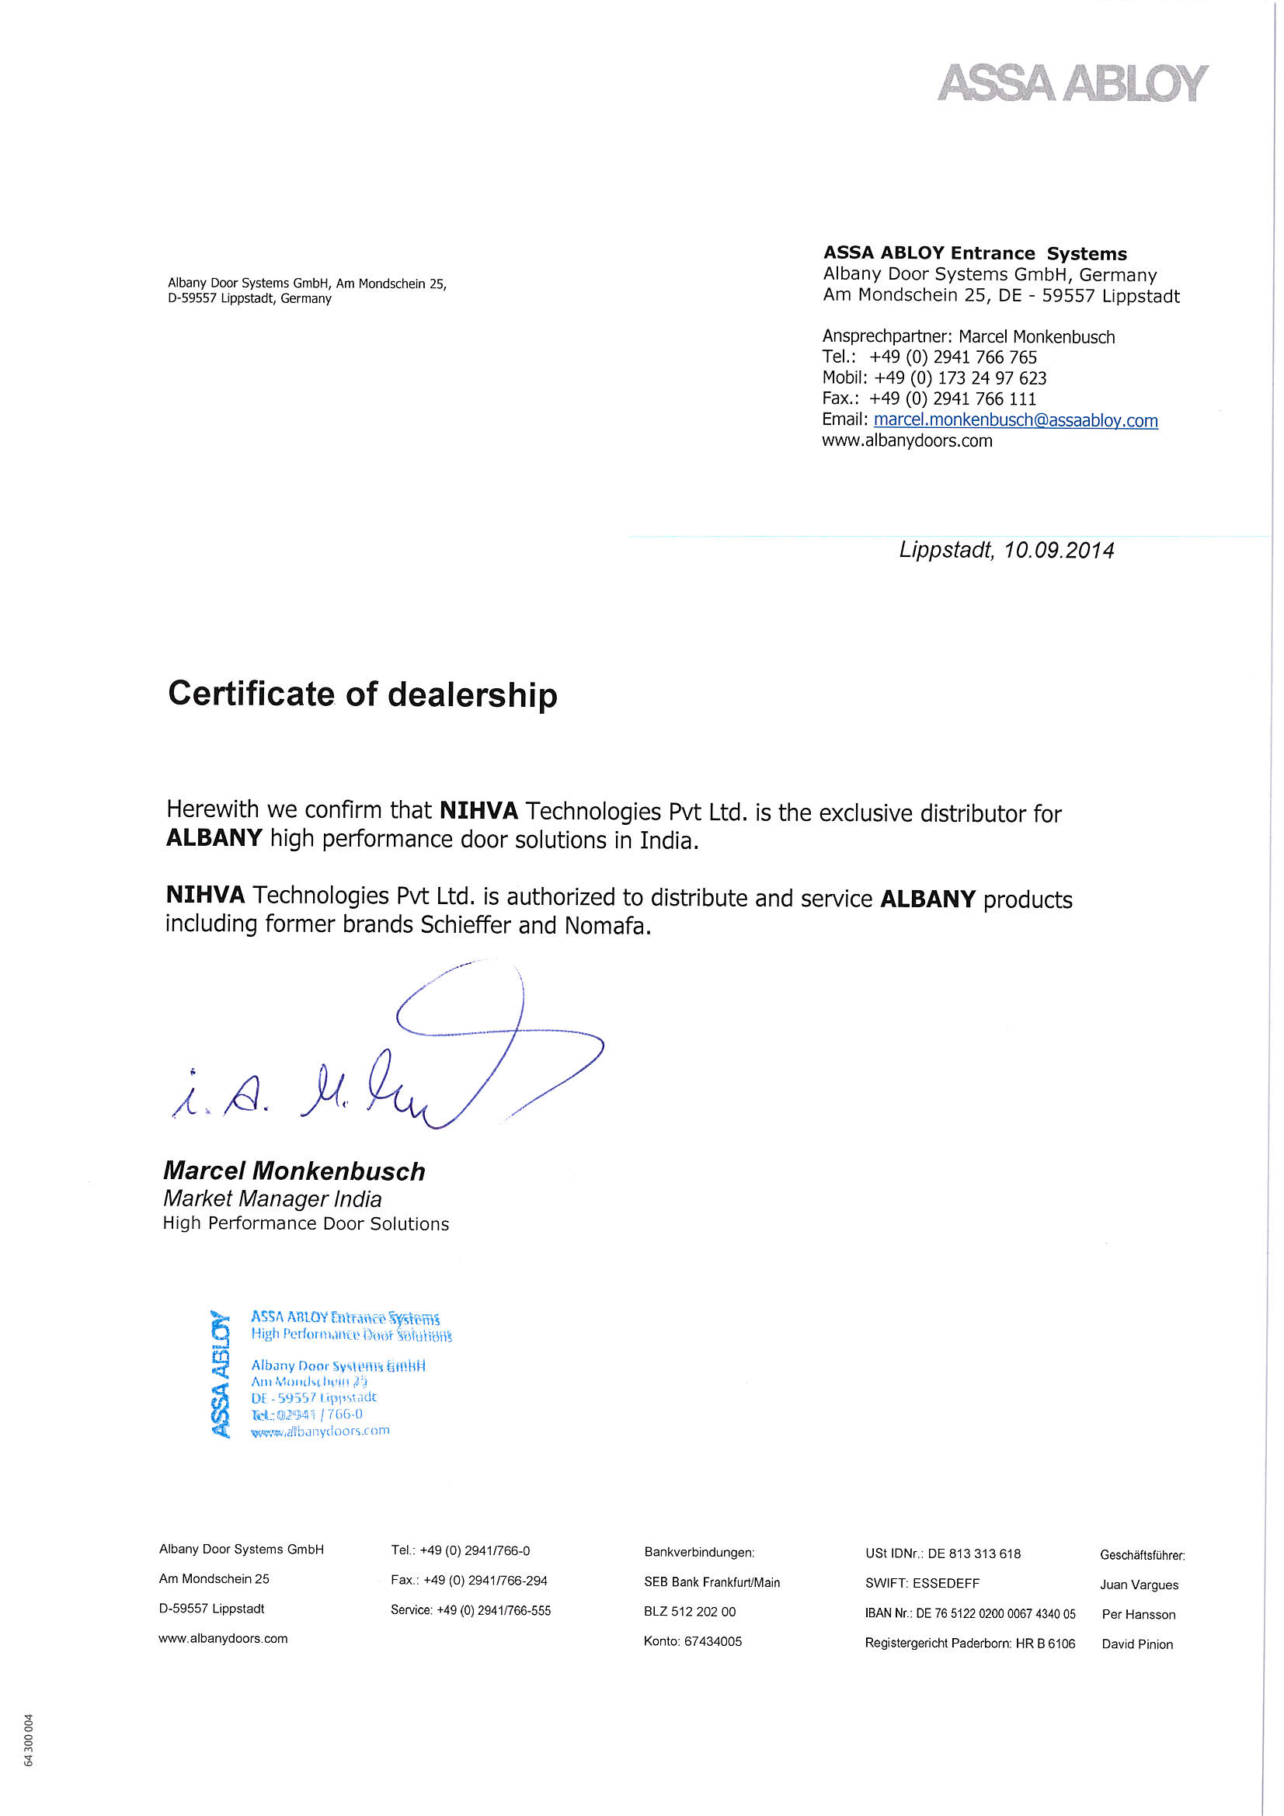
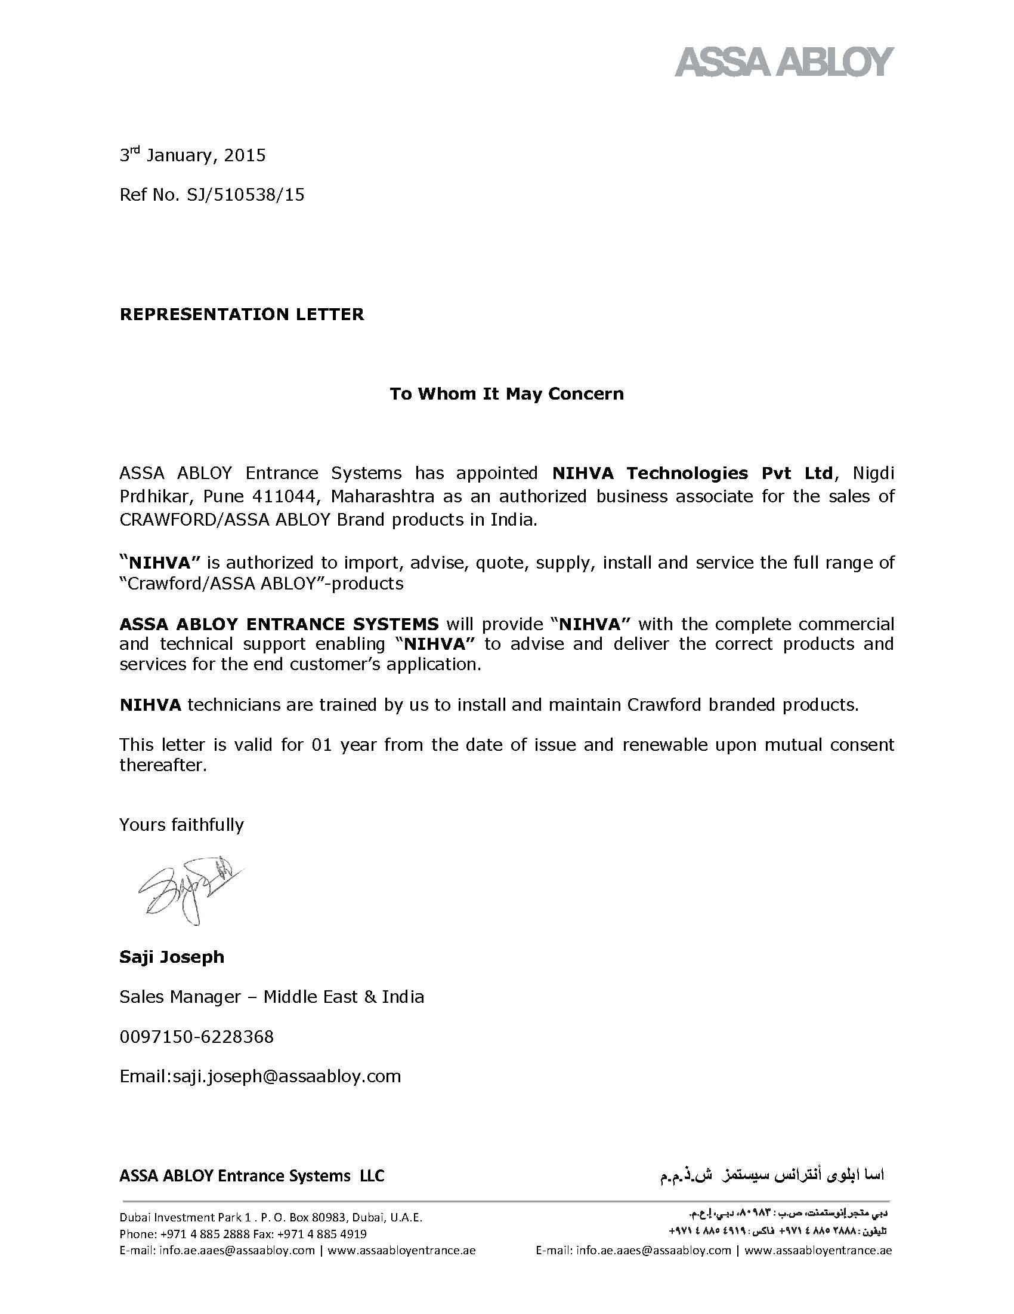

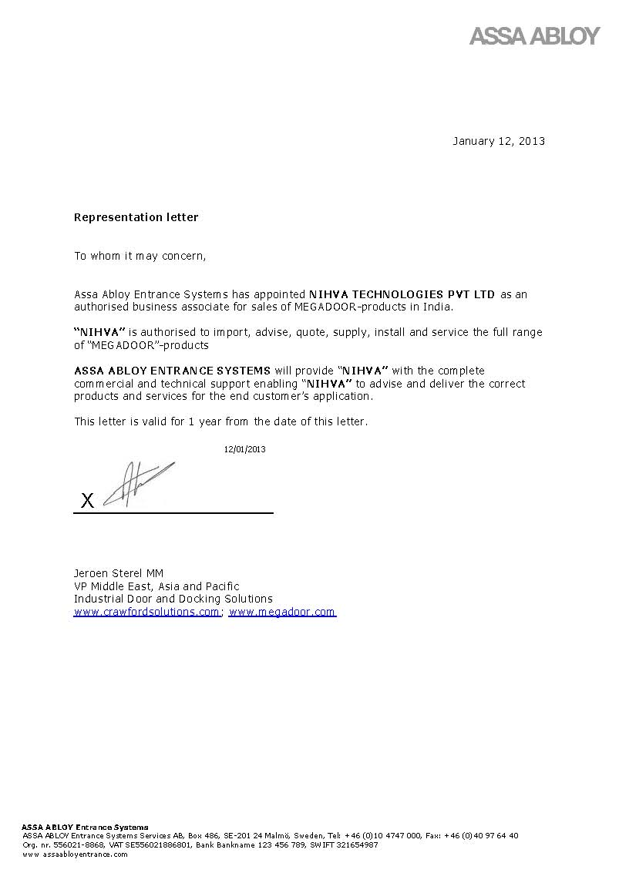

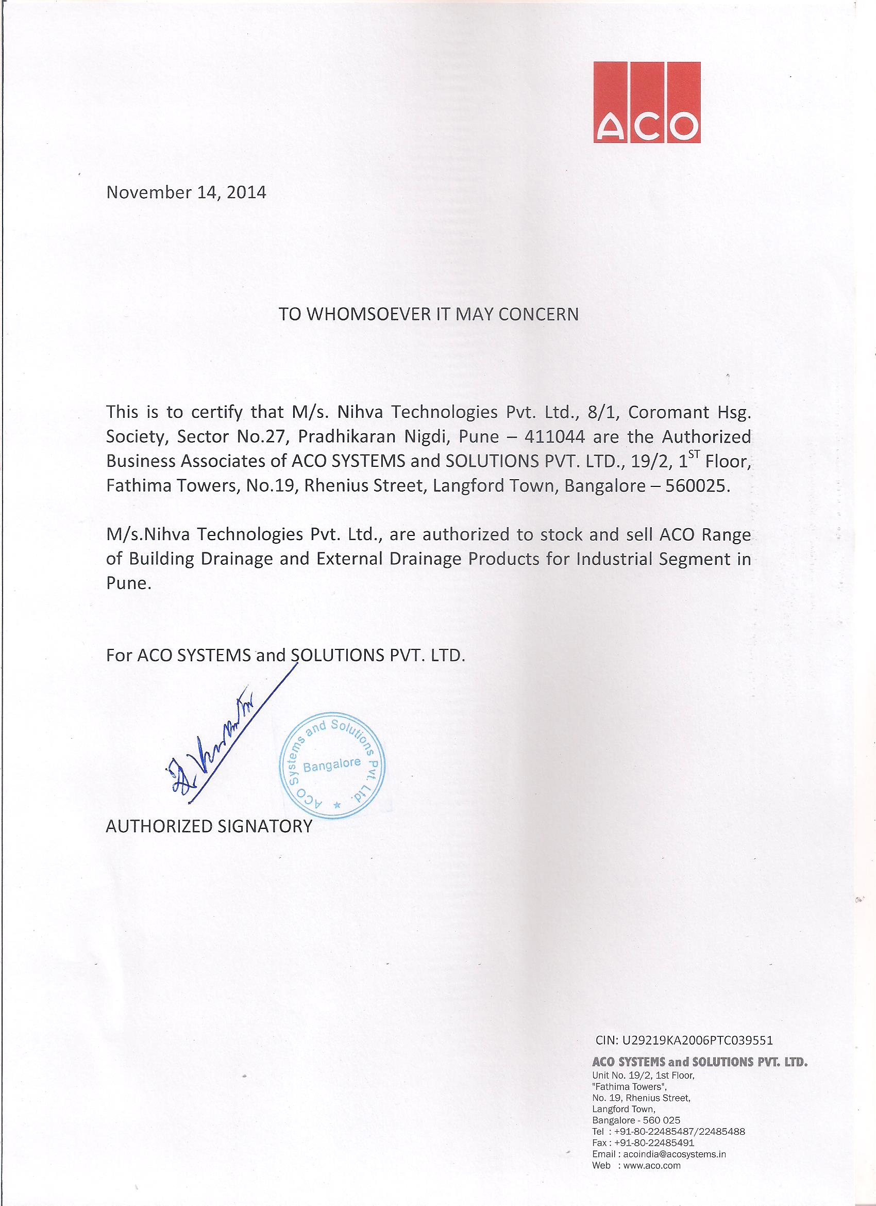

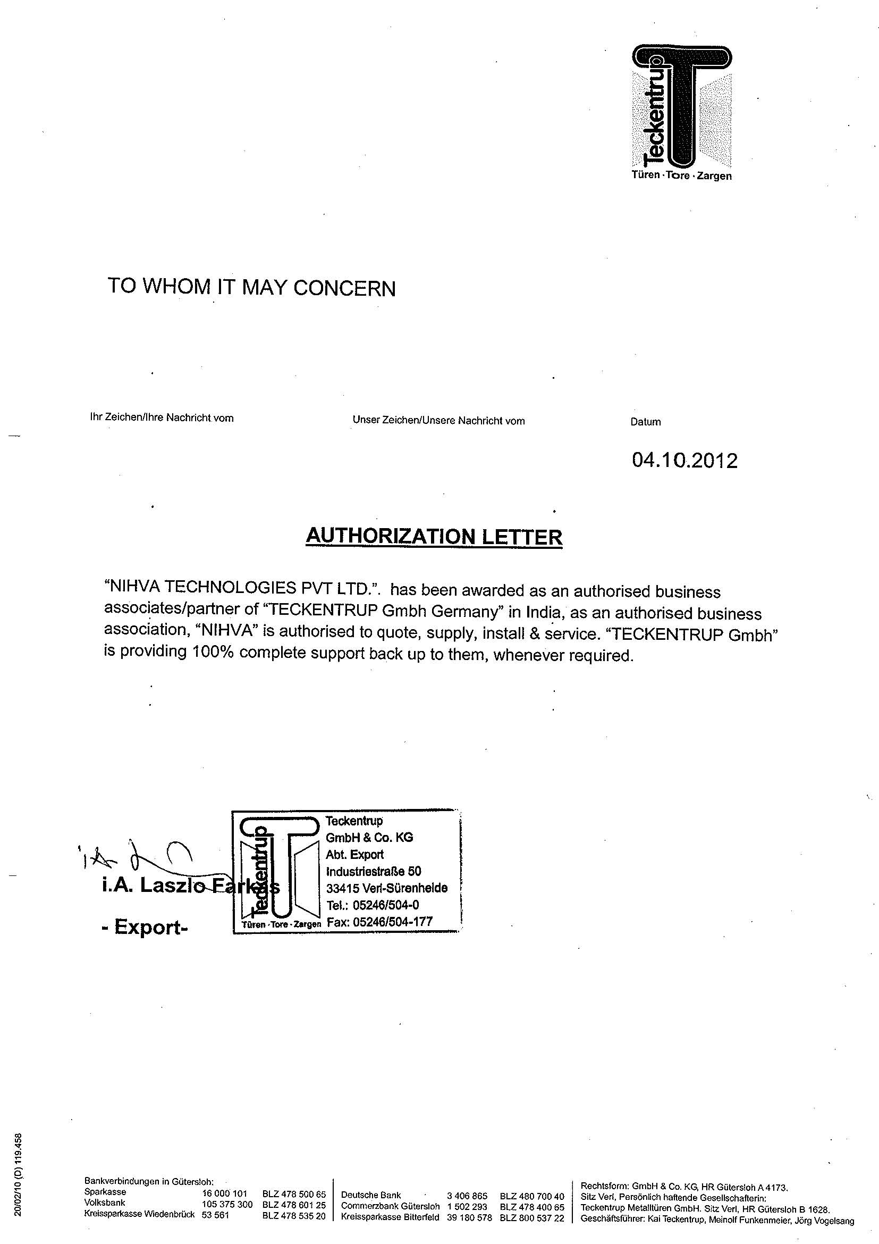

Product Solutions

Product Solutions


The world is becoming more globalized and open, and the way we protect ourselves is evolving. Safety and security remain essential, but the need for openness and convenience is ever increasing.

At NIHVA ASSA ABLOY we apply intelligent technology to optimize the security, safety and convenience of our door opening solutions, effectively satisfying our customers’ diverse and dynamic needs.

Intelligent openings allow our customers to be in control, unlock their potential and capture future opportunities.

Our product solutions cover doors any opening, ranging from garage openings, industrial doors, docking, high performance doors and also hangar applications.

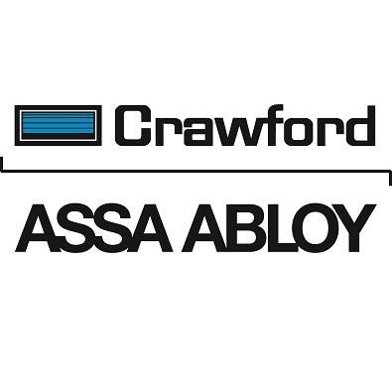
Industrial Doors & Docking Solutions:

  - Over Head Sectional Doors
  - Garage Doors
  - Dock Levelers
  - Dock Shelters
  - Docking Equipment
  - High Speed doors

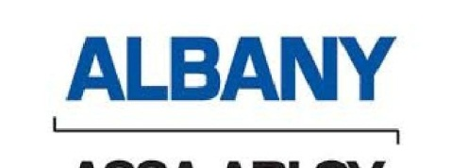

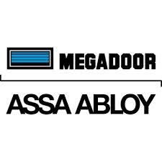
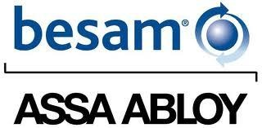
High Performance Doors:

- Rapid Roll - Rigid Curtain type
- Rapid Roll - Flexible Curtain type
- Freezer Doors
- Strip curtains and metal roll up doors

Hangar Doors & Industrial doors:

- Hangar door application
- Industrial environment doors

Automatic Glass doors:

  - Sliding doors
  - Swing doors
  - Revolving Doors

Automation Solutions
- Control Panel
    - LT & HT
- Pick & Place Machines
    - Manipulator
    - Air Balancer
- Wireless Automation
    - M2M
- Innovative Products-Machines-Process Solutions
    - SPM
    - Vending Machines
- Packaging system
    - Any Packaging system
- Material Handling Equipment (customized)
          - : Scissor Lifts
          - : Goods Lift
          - : Telescopic Conveyors
          - : Battery Operated Pallet Truck
          - : Battery Operated Mob Crane
          - : Battery Operated Stacker
- Automatic Roofs
    - Telescopic Roof
    - Sliding Roof
    - Folding Roof
    - Tilting Roof

Our Expertise

- Power Distribution panels & Feeder Panels
- Motor Control Panel
- Water Treatment Control Panels
- Boiler control panels
- Machine Tools Control panels
- Mining & Construction control panels
- Robotics & Automation Control Panels
- Furnace control panels
- Hydraulic Press Control panels
- Automatic Power Factor Compensation Control Panels

Other Services offered:

We also offer Installation & Commissioning Services for
- Paint Shop Systems
- Boilers
- Machine Tools
- Mining & Construction Equipment
- Heat Treatment Furnaces
- Water Treatment Project
- Pharmaceutical Packaging
- Robotics and Conveyors
- Hydraulic Power pack

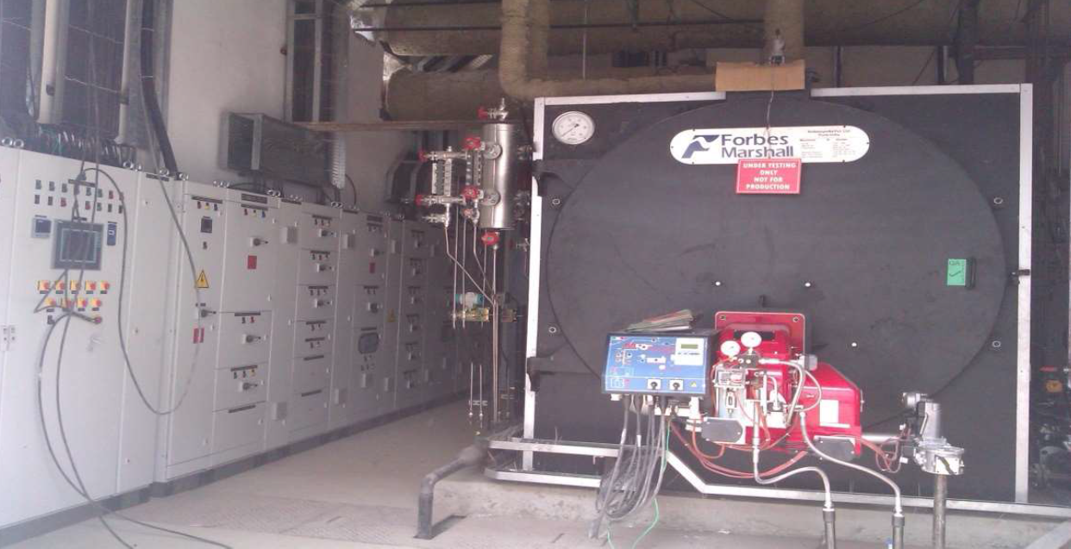
Boiler Control Panel

PLC controlled Boiler Control
Panel as designed using RITTAL
Compartmentalized Fabrication
including Software & PLC
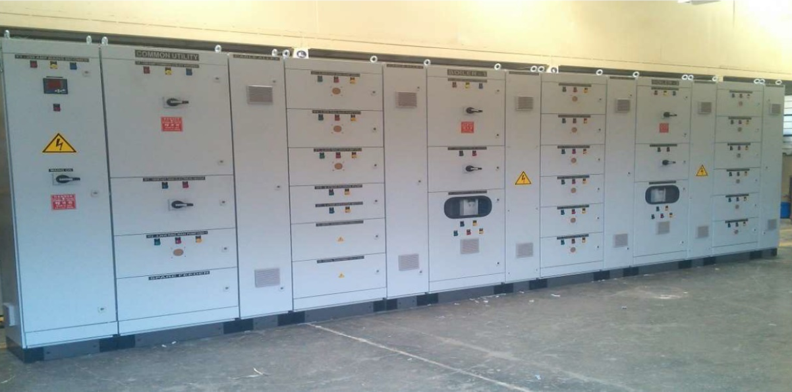
Programming

Water Treatment

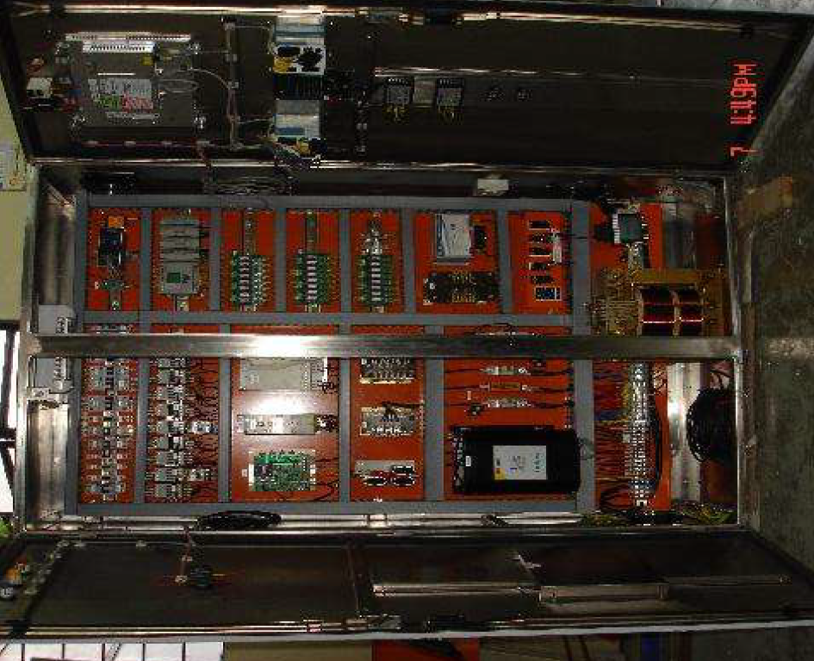

Crusher Panel – EMC
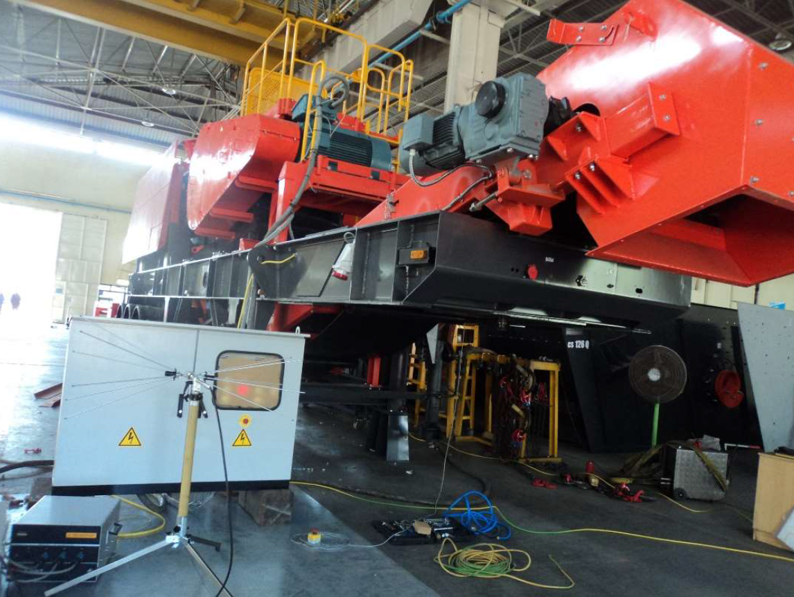
During EMC testing being carried.
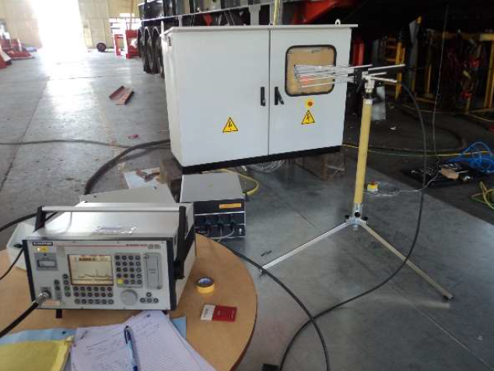

Paint Booth Panel

Paint Booth Automation Panel with Software & Programming support

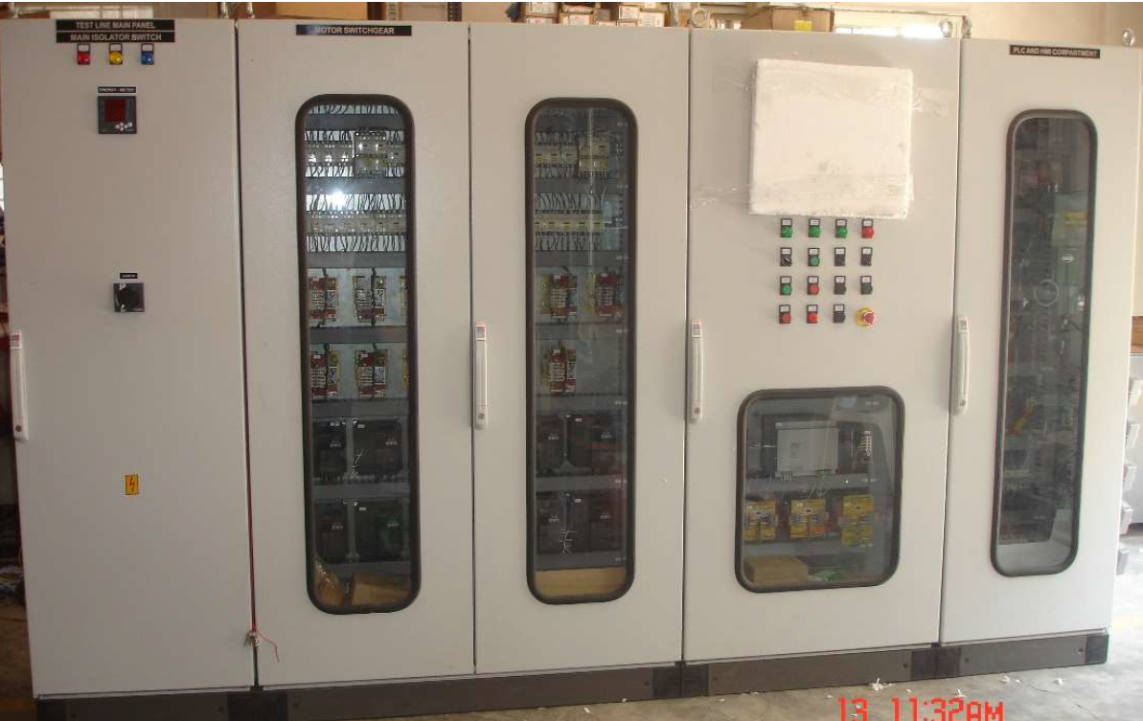
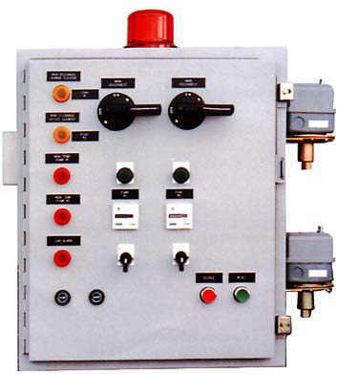
Multi Motor Driver Industrial Control Panel
UL Listed Control Panel
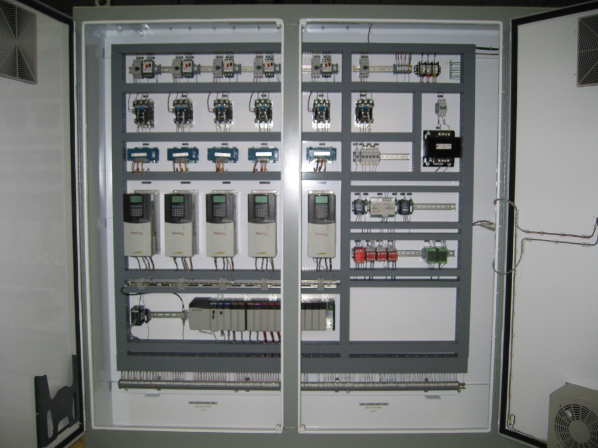
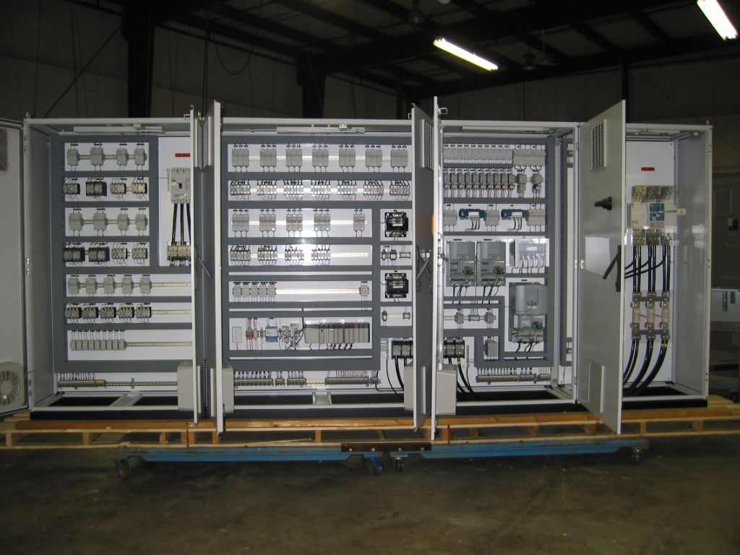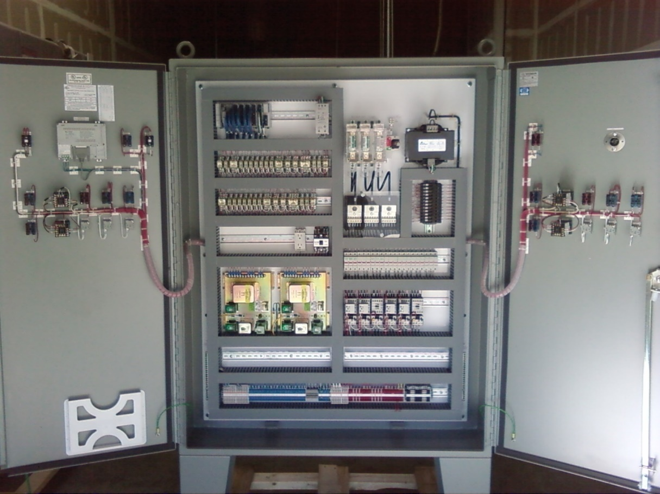
HT Control Panel
HT Control Panel

Automation Solutions

Pick & Place Machines :
- Manipulator
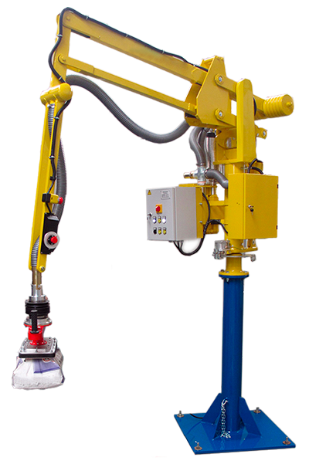
- Air Balancer
- Wireless Automation : M2M

- Innovative Products-Machines-Process Solutions
: SPM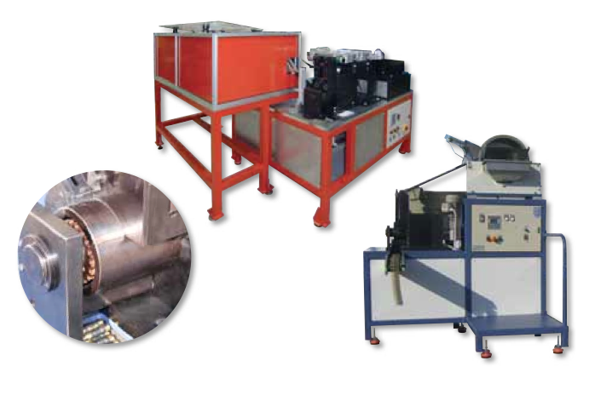
- Vending Machines
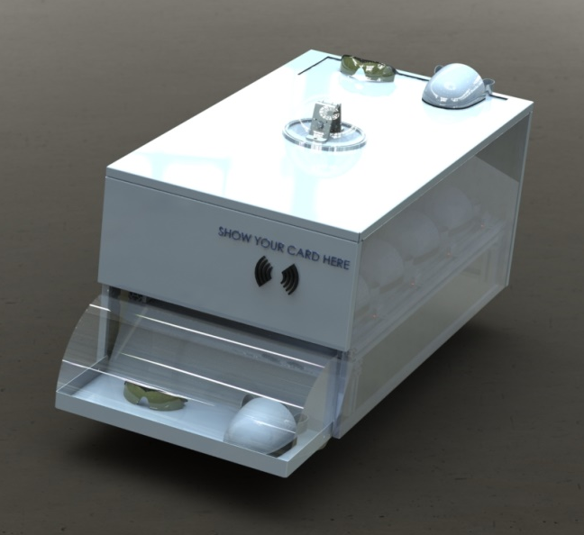

- Packaging system:
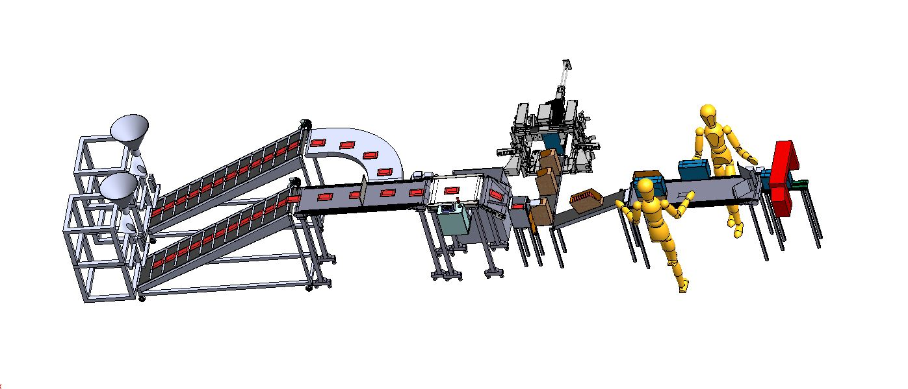
  - Any Packaging system

Material Handling Equipment (customized)
: Scissor Lifts
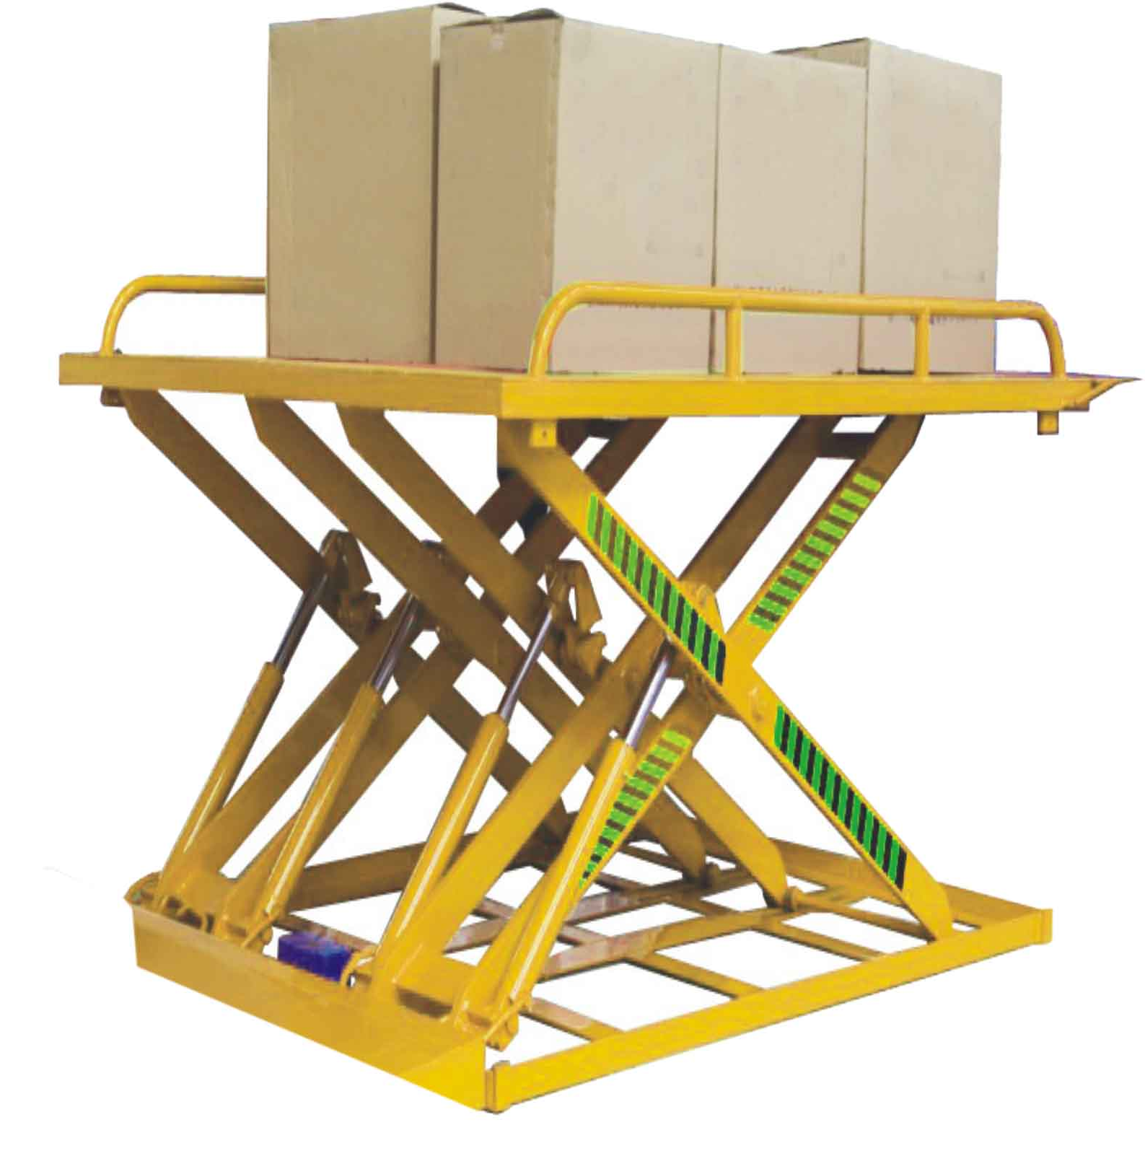
: Goods Lift

: Telescopic Conveyors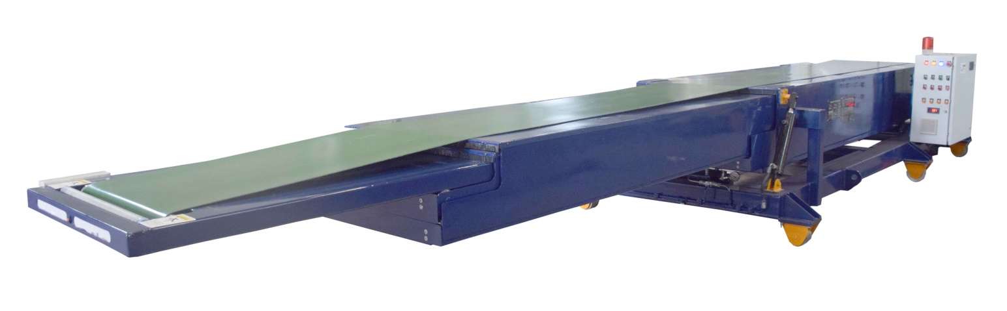

: Battery Operated Pallet Truck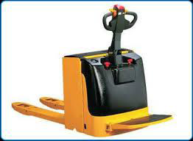
: Battery Operated Mob Crane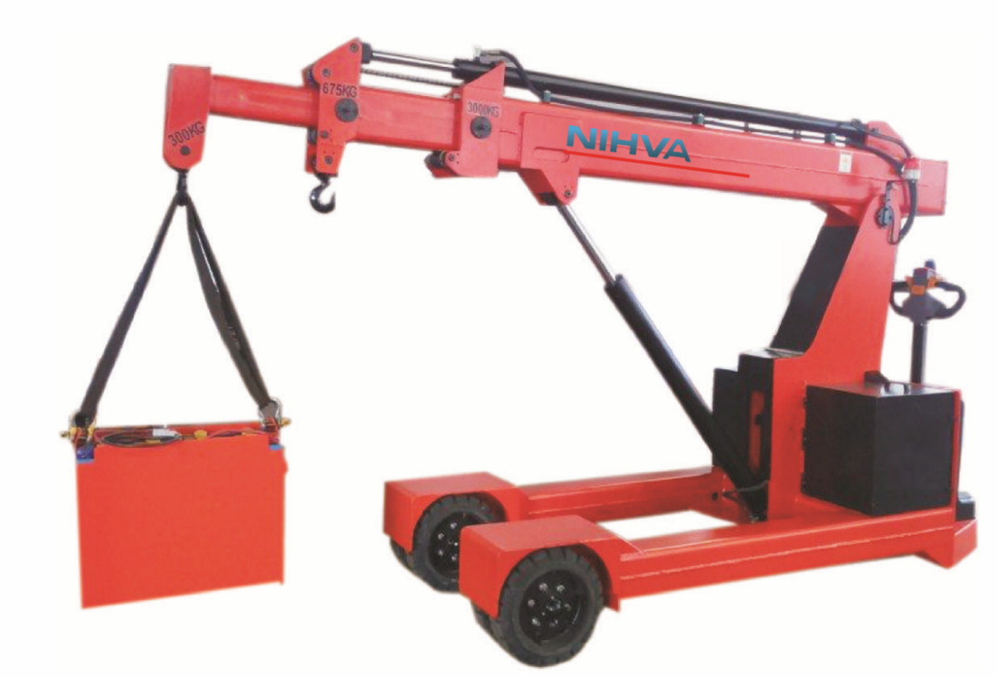
Roof: Automatic Roofs
: Telescopic Roof : Sliding Roof

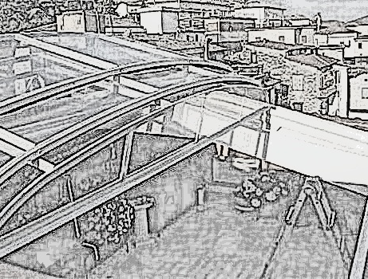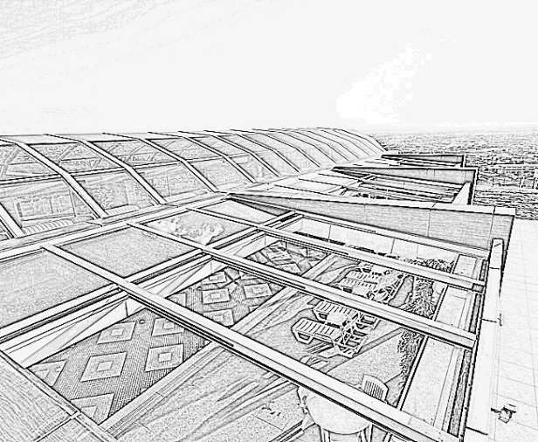

: Folding Roof : Tilting Roof
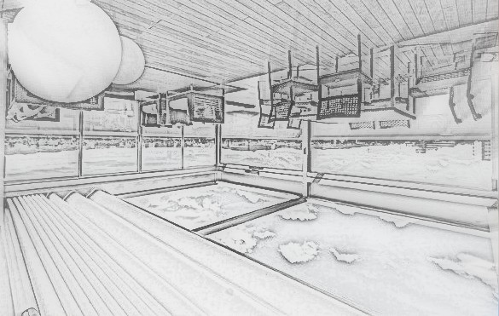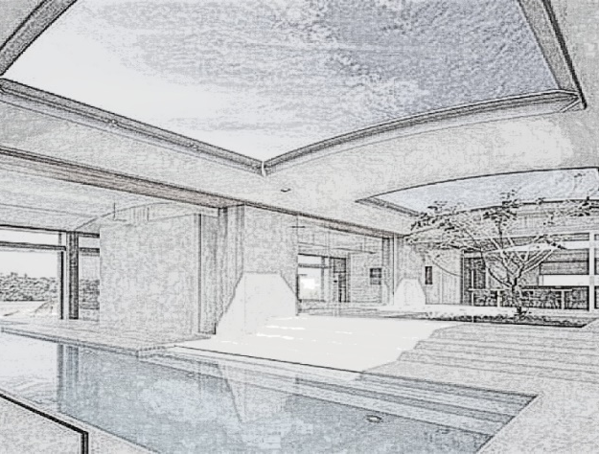

Client List



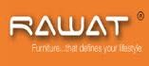


End User / Client Reference List (Major & Selective)

“NIHVA” is the leading brand, pioneer in offering solutions in comprehensive range of Automations. We take pride that our product & service range is offered with a high level of working safety, comfort, functionality and supported by services and added value solutions.

Our scope of work starts from understanding need, real requirement, application, site visit, consulting, design& customization, supply, installation and commissioning along with complete service back-up.

Our aim to create a solution for every automation need, control on man, material & money. Today we backed up by strong portfolio of global brands with local solution and 24/7 service support.

Automobile

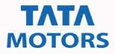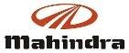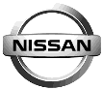

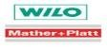
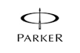
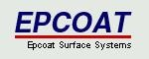
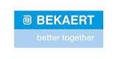

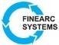
Industrial

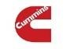






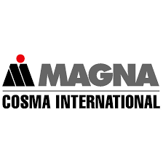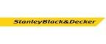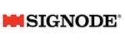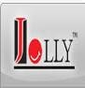






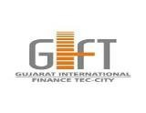








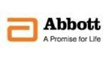

Food

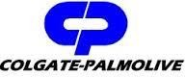
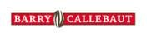
Contractor / PEB
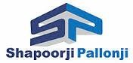


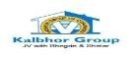
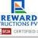

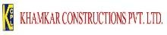






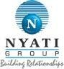
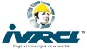

Architects / PMC



